|  |
| --- |
|  |
| Dimension and Facts Basics |

|  |  |  |  |  |  |
| --- | --- | --- | --- | --- | --- |
| REVISION HISTORY | | | | | |
| Ver. | Description of Change | Author | Date | Approved | |
| Name | Effective Date |
| 1.0 | Initial status | Valeryia\_Lupanava | 09-NOV-2017 |  |  |

Contents

[1. Data Description 3](#_Toc498028520)

[2. Dimensions of a Business 4](#_Toc498028521)

[2.1. Definition of selected Business Process 4](#_Toc498028522)

[2.2. Declaring the Grain 4](#_Toc498028523)

[2.3. Identifying the Dimensions 4](#_Toc498028524)

[2.4. Identifying the Facts 7](#_Toc498028525)

[2.5. Dimensional model. Star Schema 8](#_Toc498028526)

[2.5.1. Product part dimensions 9](#_Toc498028527)

[2.5.2. Store part dimensions 9](#_Toc498028528)

[2.5.3. Customer part dimensions 10](#_Toc498028529)

[2.5.4. Promotion dimensions 10](#_Toc498028530)

[2.5.5. Sales employee dimension 10](#_Toc498028531)

[2.5.6. Payment method dimension 10](#_Toc498028532)

[2.5.7. Date dimension 11](#_Toc498028533)

# Data Description

Customer and manager information was generated on the site [www.mockaroo.com](http://www.mockaroo.com/). It allows creating file with 1000 rows.

Additionally, manager information was modified in the Excel. There was added column “Position name”. Information in that column was created by the specific random formula.

Information for Collection, Line, Product type, Store dimensions is on the official company’s site [www.milavitsa.com](http://www.milavitsa.com/). Information about Sizes can be find via tne next links [www.milavitsa.com/collections/converter](http://www.milavitsa.com/collections/converter/) and [www.globebrand.com/sizing\_charts](https://www.globebrand.com/sizing_charts)

Business rules:

1. Every **Retail Sale** must be associated with a valid **Customer**.
2. A **Retail Sale** is always associated with a **Payment Method**.
3. A **Retail Sale** can have one or many **Products**.
4. A **Retail Sale** is always associated with a specific **Employee**.

# Dimensions of a Business

## Definition of selected Business Process

Business Process for analysis is Milavitsa’s sales per different metrics.

## Declaring the Grain

Fact granularity is Daily Sales Amount per certain Customer and Employee in a specific a Store.

## Identifying the Dimensions

Schema should contains next dimensions:

1. Customer part dimensions:
   * Customer dimension (parent dimension);

|  |  |  |
| --- | --- | --- |
| **Column Name** | **Data Type** | **Descroption** |
| customer\_id | NUMBER(10) | Primary Key |
| first\_name | VARCHAR2(40 BYTE) |  |
| last\_name | VARCHAR2(40 BYTE) |  |
| age | NUMBER(2) |  |
| email | VARCHAR2(40 BYTE) |  |
| phone | VARCHAR2(40 BYTE) |  |
| address\_id | NUMBER(10) | Foreign Key |

* + Customer location dimension (child dimension);

|  |  |  |
| --- | --- | --- |
| **Column Name** | **Data Type** | **Descroption** |
| address\_id | NUMBER(10) | Primary Key |
| postal\_code | NUMBER(10) |  |
| address | VARCHAR2(20 BYTE) |  |
| city | VARCHAR2(20 BYTE) |  |
| country | VARCHAR2(20 BYTE) |  |
| region | VARCHAR2(20 BYTE) |  |

1. Product part dimensions:
   * Product dimension (parent dimension);

|  |  |  |
| --- | --- | --- |
| **Column Name** | **Data Type** | **Descroption** |
| product\_id | NUMBER(10) | Primary Key |
| product\_code | NUMBER(10) |  |
| collection\_id | NUMBER(10) | Foreign Key |
| line\_id | NUMBER(10) | Foreign Key |
| product\_type\_id | NUMBER(10) | Foreign Key |
| product\_name | VARCHAR2(10 BYTE) |  |
| product\_description | VARCHAR2(40 BYTE) |  |
| size\_id | NUMBER(10) | Foreign Key |
| color | VARCHAR2(40 BYTE) |  |
| price | NUMBER(10) |  |
| product\_balance | NUMBER(10) |  |

* + Collection dimension (child dimension);

|  |  |  |
| --- | --- | --- |
| **Column Name** | **Data Type** | **Descroption** |
| collection\_id | NUMBER(10) | Primary Key |
| collection\_name | VARCHAR2(10 BYTE) |  |
| collection\_season | VARCHAR2(10 BYTE) |  |
| collection\_descriptio | VARCHAR2(40 BYTE) |  |
| collection\_date | DATE |  |

* + Line dimension (child dimension);

|  |  |  |
| --- | --- | --- |
| **Column Name** | **Data Type** | **Descroption** |
| line\_id | NUMBER(10) | Primary Key |
| line\_name | VARCHAR2(10 BYTE) |  |
| line\_description | VARCHAR2(40 BYTE) |  |

* + Product type description (child dimension);

|  |  |  |
| --- | --- | --- |
| **Column Name** | **Data Type** | **Descroption** |
| product\_type\_id | NUMBER(10) | Primary Key |
| product\_type | VARCHAR2(10 BYTE) |  |

* + Size grid description (child dimension);

|  |  |  |
| --- | --- | --- |
| **Column Name** | **Data Type** | **Descroption** |
| size\_id | NUMBER(10) | Primary Key |
| size\_code | VARCHAR2(10 BYTE) |  |
| country\_standart\_code | VARCHAR2(10 BYTE) |  |
| sex | VARCHAR2(10 BYTE) |  |

1. Store part dimensions:
   * Store dimension (parent dimension);

|  |  |  |
| --- | --- | --- |
| **Column Name** | **Data Type** | **Descroption** |
| store\_id | NUMBER(10) | Primary Key |
| manager\_id | NUMBER(10) | Foreign Key |
| phone | VARCHAR2(40 BYTE) |  |
| address\_id | NUMBER(10) | Foreign Key |

* + Store location dimension (child dimension);

|  |  |  |
| --- | --- | --- |
| **Column Name** | **Data Type** | **Descroption** |
| address\_id | NUMBER(10) | Primary Key |
| postal\_code | NUMBER(10) |  |
| address | VARCHAR2(20 BYTE) |  |
| city | VARCHAR2(20 BYTE) |  |
| country | VARCHAR2(20 BYTE) |  |
| region | VARCHAR2(20 BYTE) |  |

* + Manager dimension (child dimension);

|  |  |  |
| --- | --- | --- |
| **Column Name** | **Data Type** | **Descroption** |
| manager\_id | NUMBER(10) | Primary Key |
| first\_name | VARCHAR2(40 BYTE) |  |
| last\_name | VARCHAR2(40 BYTE) |  |
| position\_name | VARCHAR2(40 BYTE) |  |
| email | VARCHAR2(40 BYTE) |  |
| phone | VARCHAR2(40 BYTE) |  |

1. Payment method dimension;

|  |  |  |
| --- | --- | --- |
| **Column Name** | **Data Type** | **Descroption** |
| payment\_method\_id | NUMBER(10) | Primary Key |
| payment\_method\_name | VARCHAR2(40 BYTE) |  |
| bank\_name | VARCHAR2(40 BYTE) |  |

1. Sales employee dimension;

|  |  |  |
| --- | --- | --- |
| **Column Name** | **Data Type** | **Descroption** |
| sales\_employee\_id | NUMBER(10) | Primary Key |
| first\_name | VARCHAR2(40 BYTE) |  |
| last\_name | VARCHAR2(40 BYTE) |  |
| position\_grade | VARCHAR2(40 BYTE) |  |
| position\_name | VARCHAR2(40 BYTE) |  |
| email | VARCHAR2(40 BYTE) |  |
| phone | VARCHAR2(40 BYTE) |  |
| start\_date | DATE |  |

1. Promotion dimension;

|  |  |  |
| --- | --- | --- |
| **Column Name** | **Data Type** | **Descroption** |
| promotion\_id | NUMBER(10) | Primary Key |
| promotion\_type | VARCHAR2(40 BYTE) |  |
| promotion\_description | VARCHAR2(40 BYTE) |  |
| promotion\_price | NUMBER(10) |  |
| price\_decreasing\_percent | NUMBER(10) |  |
| free\_unit\_amount | NUMBER(10) |  |
| start\_date | DATE |  |
| end\_date | DATE |  |

1. Date dimension.

|  |  |  |
| --- | --- | --- |
| **Column Name** | **Data Type** | **Descroption** |
| date\_id | NUMBER(10) | Primary Key |
| fulldate | VARCHAR2(10) |  |
| dayofmonth | VARCHAR2(2) |  |
| dayname | VARCHAR2(9) |  |
| dayofweek | VARCHAR2(1) |  |
| dayofweekinmonth | VARCHAR2(2) |  |
| dayofweekinyear | VARCHAR2(2) |  |
| dayofquarter | VARCHAR2(3) |  |
| dayofyear | VARCHAR2(3) |  |
| weekofmonth | VARCHAR2(1) |  |
| weekofquarter | VARCHAR2(2) |  |
| weekofyear | VARCHAR2(2) |  |
| monthnumber | VARCHAR2(2) |  |
| monthname | VARCHAR2(9) |  |
| monthofquarter | VARCHAR2(2) |  |
| quarter | VARCHAR2(1) |  |
| quartername | VARCHAR2(9) |  |
| yearnumber | VARCHAR2(4) |  |
| monthyear | VARCHAR2(10) |  |
| firstdayofmonth | DATE |  |
| lastdayofmonth | DATE |  |
| firstdayofquarter | DATE |  |
| lastdayofquarter | DATE |  |
| firstdayofyear | DATE, |  |
| lastdayofyear | DATE, |  |

## Identifying the Facts

Schema should contains the fact table “Retail sales fact” with next data:

1. Sales\_id;
2. Receipt\_number;
3. Date\_id;
4. Product\_id;
5. Sales\_employee\_id;
6. Customer\_id;
7. Store\_id;
8. Payment\_method\_id;
9. Promotion\_id;
10. Receipt\_sum;
11. Unit\_amount.

|  |  |  |
| --- | --- | --- |
| **Column Name** | **Data Type** | **Descroption** |
| sales\_id | NUMBER(10) | Surrogate identifier of one purchase |
| receipt\_number | NUMBER(10) | Unique number of receipt – natural identifier of one purchase |
| date\_id | NUMBER(10) | Foreign Key |
| product\_id | NUMBER(10) | Foreign Key |
| sales\_employee\_id | NUMBER(10) | Foreign Key |
| customer\_id | NUMBER(10) | Foreign Key |
| store\_id | NUMBER(10) | Foreign Key |
| payment\_method\_id | NUMBER(10) | Foreign Key |
| promotion\_id | NUMBER(10) | Foreign Key |
| receipt\_sum | NUMBER(10) | Total sum per a certain receipt |
| unit\_amount | NUMBER(10) | Total amount of units per a certain receipt |

## C:\Users\Valeryia\Desktop\Valeryia_Lupanava\reports\Valeryia_Lupanava_Labwork_07\Snowflake_schema.jpgDimensional model. Star Schema

### Product part dimensions

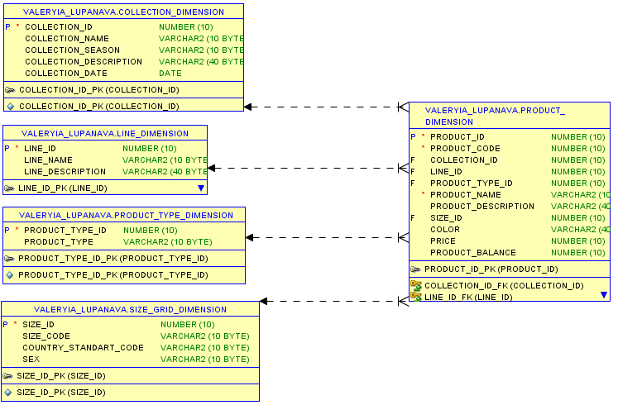

### Store part dimensions

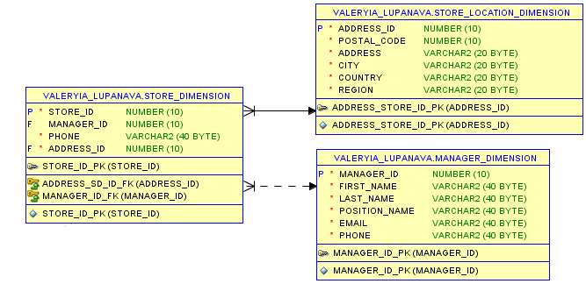

### Customer part dimensions

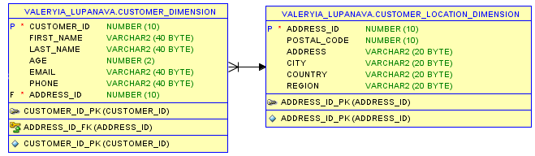

### Promotion dimensions

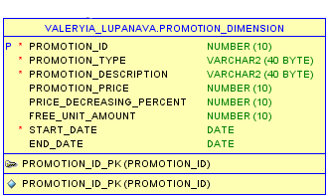

### Sales employee dimension

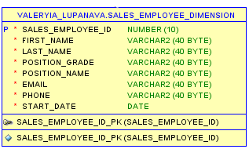

### Payment method dimension

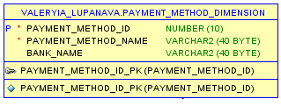

### Date dimension

